א. רבי יהודה הלוי - "כוזרי" מאמר שני סעיף כו ומאמר חמישי סעיפים א-ב + רבי נחמן מברסלב " ליקוטי מוהר"ן תנינא [ אות יט]

- קיץ תשע"ד 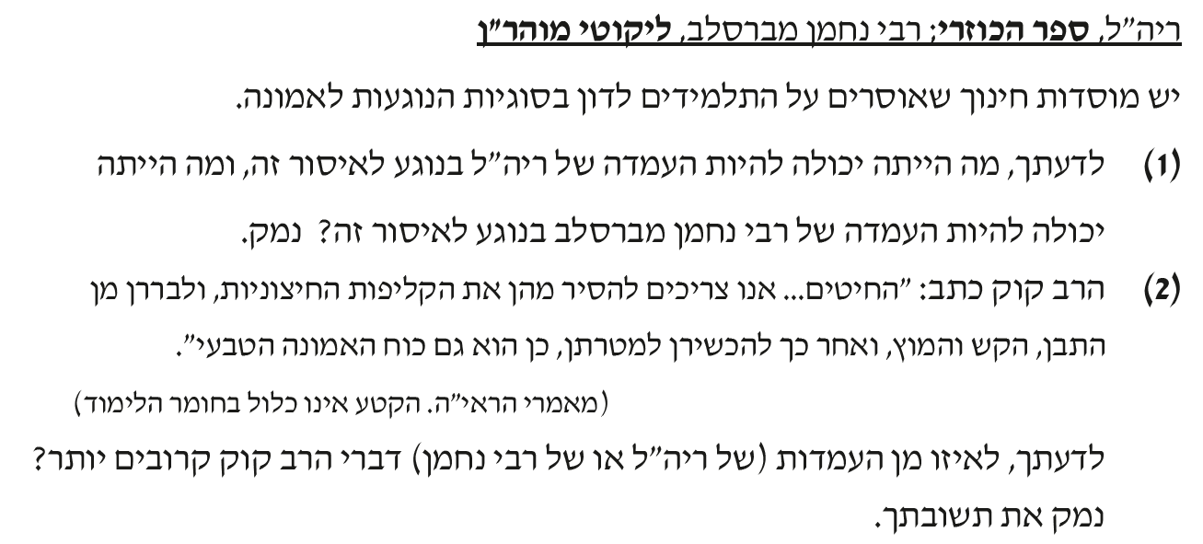
____________________________________________________________________________________________________________________________________________________________________________________________________________________________________________________________________________________________________________________________________________________
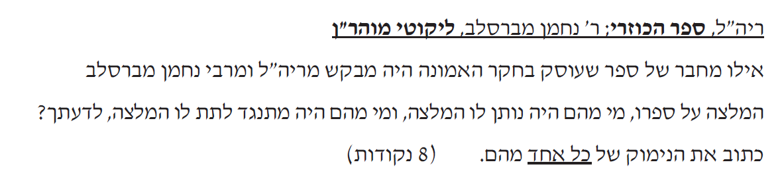
2. חורף תשע"ז ________________________________________________________________________________________________________________________________________________________________________________________________________________________________________________________________________________________________________
3. קיץ תשע"ז
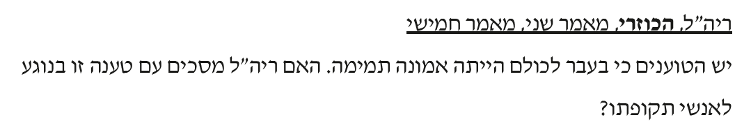
____________________________________________________________________________________________________________________________________________________

4. קיץ תשע"ח
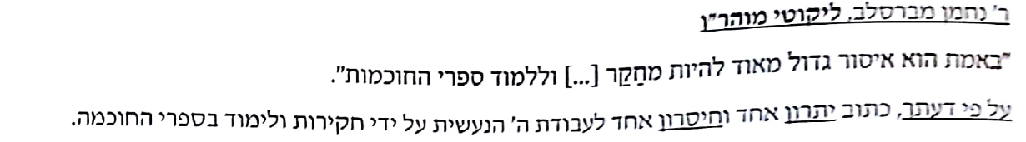
____________________________________________________________________________________________________________________________________________________

ב. רב סעדיה גאון [ רס"ג ] - ההקדמה לספר "אמונות ודעות"
- קיץ תשע"ב

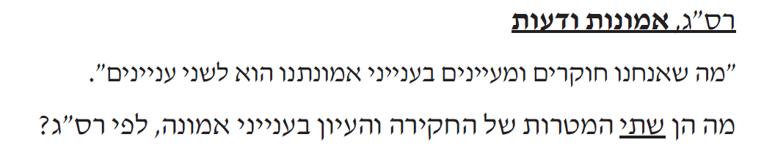
____________________________________________________________________________________________________________________________________________________

2. קיץ תשע"ג
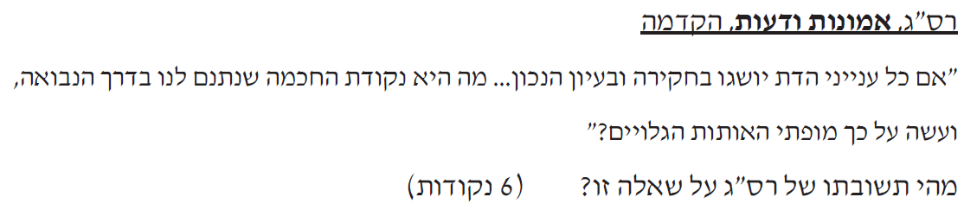
____________________________________________________________________________________________________________________________________________________

3. קיץ תשע"ה
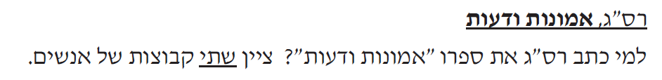
______________________________________________________________________________________________________________________________________________________________________________________________________________________________

4. חורף תשע"ח
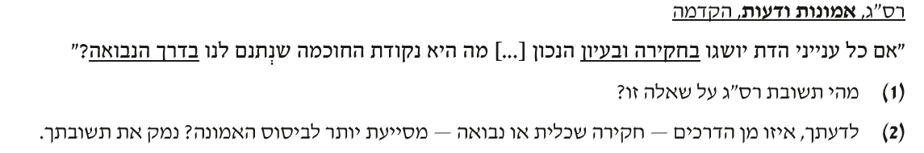
________________________________________________________________________________________________________________________________________________________________________________________________________________________________________________________________________________________________________
5. קיץ תשע"ח
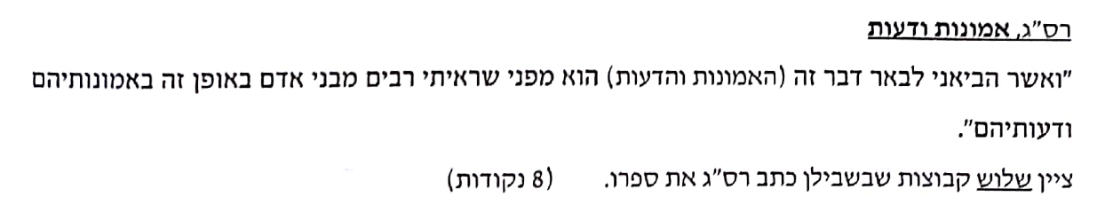
____________________________________________________________________________________________________________________________________________________

ג. רמח"ל - מתוך ההקדמה למסילת ישרים
- קיץ תשע"ב
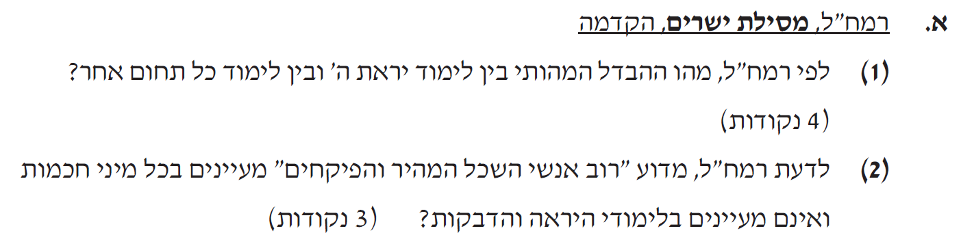________________________________________________________________________________________________________________________________________________________________________________________________________________________________________________________________________________________________________

2. קיץ תשע"ד
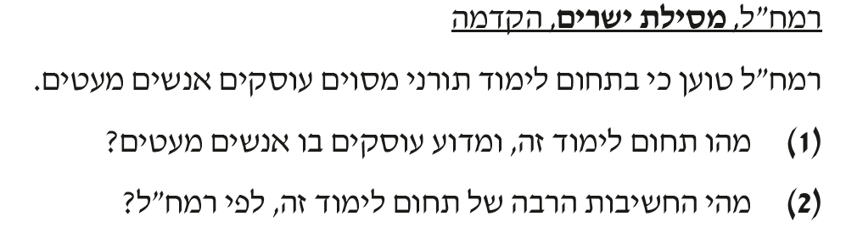________________________________________________________________________________________________________________________________________________________________________________________________________________________________________________________________________________________________________

3. קיץ תשע"ו
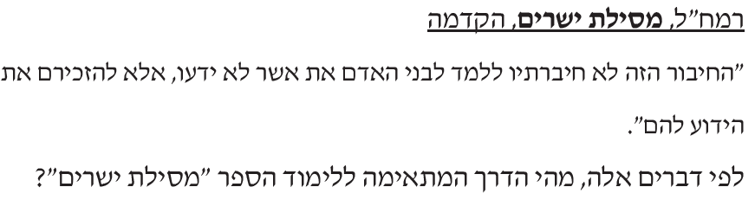
____________________________________________________________________________________________________________________________________________________

4. חורף תשע"ח
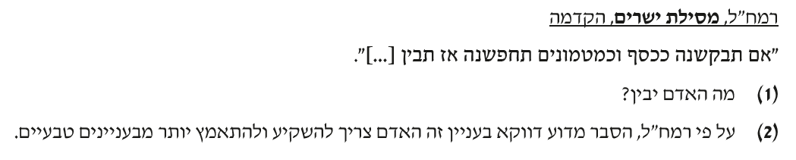______________________________________________________________________________________________________________________________________________________________________________________________________________________________
ד. רבינו בחיי - הקדמה לחובות הלבבות
- קיץ תשע"ה
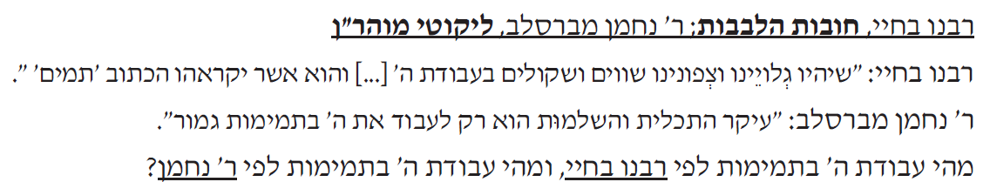
________________________________________________________________________________________________________________________________________
2. חורף תשע"ז
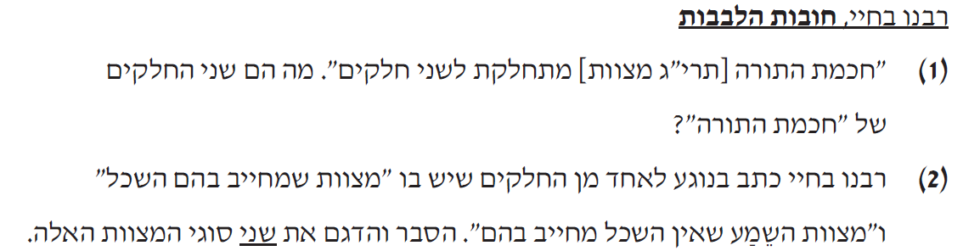
________________________________________________________________________________________________________________________________________________________________________________________________________________________________________________________________________________

3. חורף תשע"ח
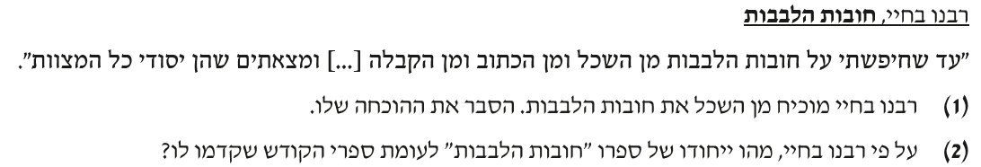
________________________________________________________________________________________________________________________________________________________________________________________________________________________________________________________________________________
4. קיץ תשע"ח
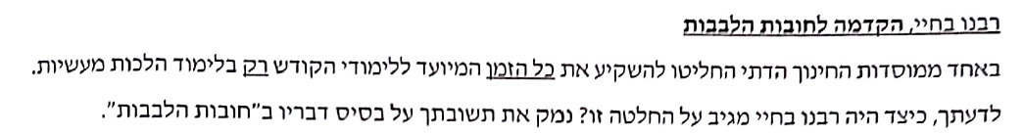

____________________________________________________________________________________________________________________________________________________________________________________________________________

ה. הראי"ה קוק - מאמר הדור

- קיץ תשע"ב
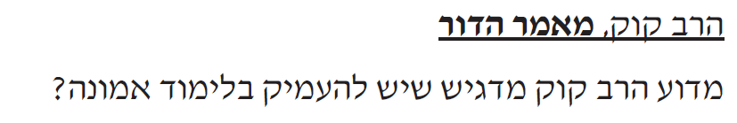
____________________________________________________________________________________________________________________________________________________________________________________________________________
2 . קיץ תשע"ד
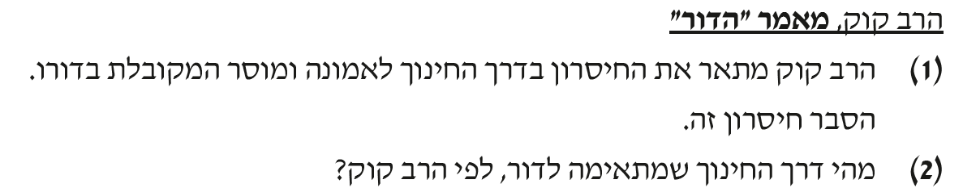
________________________________________________________________________________________________________________________________________________________________________________________________________________________________________________________________________________

3. קיץ תשע"ה
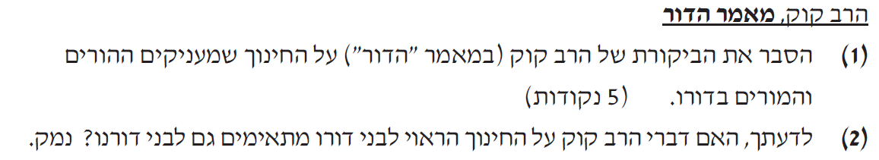
____________________________________________________________________________________________________________________________________________________________________________________________________________

4. חורף תשע"ז
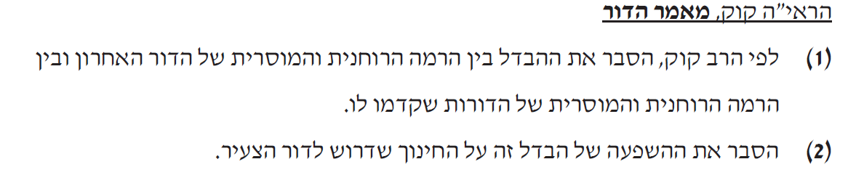
________________________________________________________________________________________________________________________________________________________________________________________________________________________________________________________________________________
5. קיץ תשע"ז
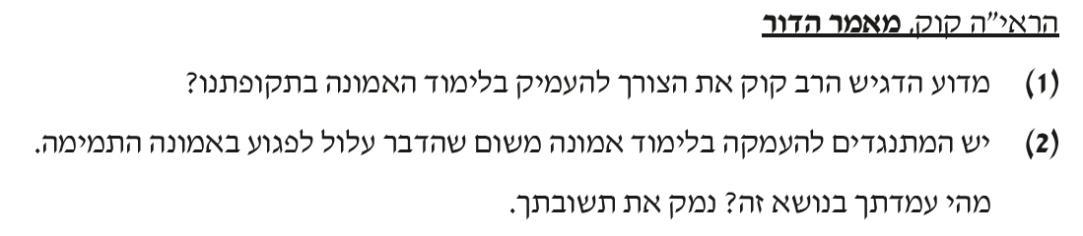
________________________________________________________________________________________________________________________________________________________________________________________________________________________________________________________________________________

ו. רבי יוסף אלבו, ספר העיקרים, מאמר ראשון, פרק י"ט
- קיץ תשע"ב

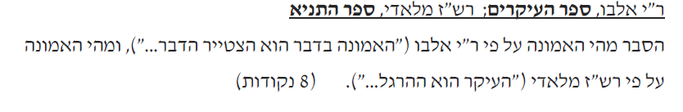
________________________________________________________________________________________________________________________________________________________________________________________________________________________________________________________________________________

ז. רבי שניאור זלמן מלאדי, "ספר התניא", פרק מ"ב
- קיץ תשע"ב - ראה לעיל ..
- קיץ תשע"ה
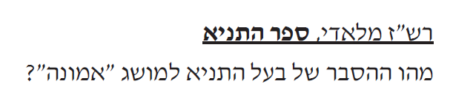
____________________________________________________________________________________________________________________________
3. חורף תשע"ח 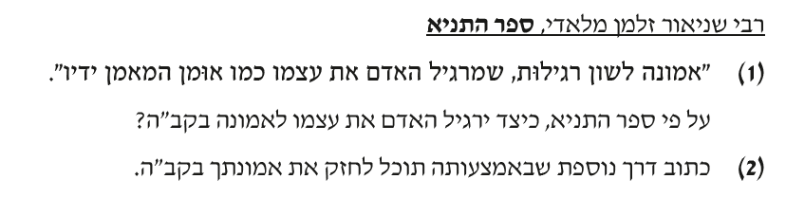
________________________________________________________________________________________________________________________________________________________________________________________________________________________________________________________________________________________________________

ח. ספר המאמרים עמ' לט - רש"ב מליובאוויטש
- קיץ תשע"ד
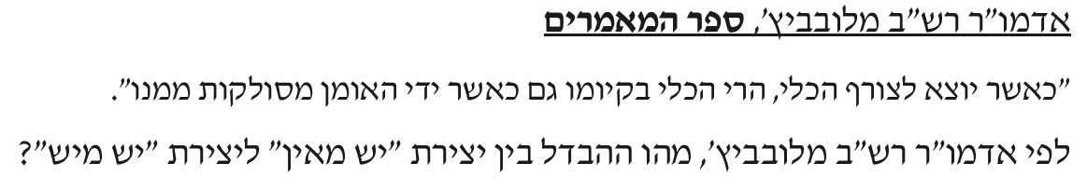_____________________________________________________________________________________________________________________________________________________________________________________________________________________________
2. קיץ תשע"ו
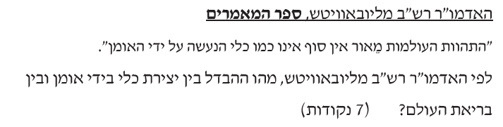
______________________________________________________________________________________________________________________________________________________________________________________________________________________________

3.קיץ תשע"ח
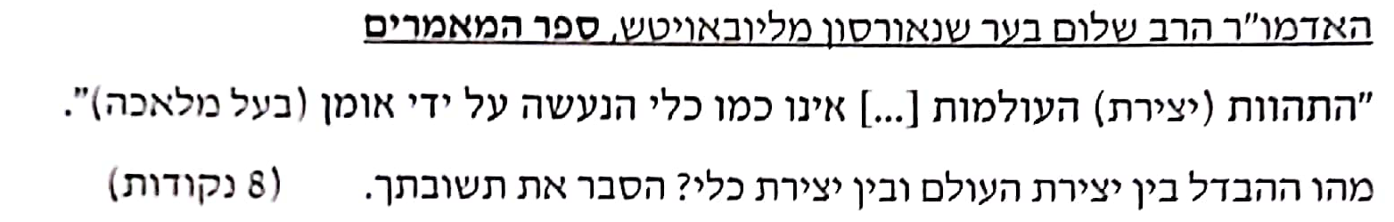
_____________________________________________________________________________________________________________________________________________________________________________________________________________________________

ט. רמב"ם יג' עיקרי האמונה מתוך פירוש למשנה , מסכת סנהדרין , ההקדמה לפרק חלק
- קיץ תשע"ב
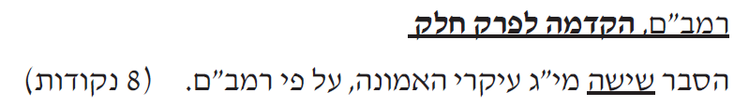
__________________________________________________________________________________________________________________________________________________________________________________________________________________________________________________________________________________________________________________________________________________________________________________
2. קיץ תשע"ג
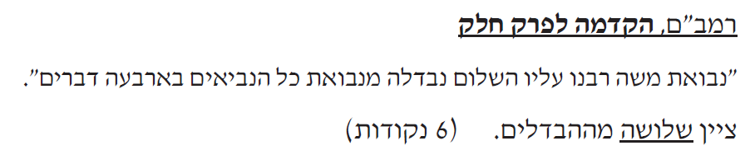
______________________________________________________________________________________________________________________________________________________________________________________________________________________________

3. חורף תשע"ז - אותה שאלה כמו בקיץ תשע"ג.
4. קיץ תשע"ז - אותה שאלה כמו בקיץ תשע"ג

י. חזון אי"ש - אמונה ובטחון
- קיץ תשע"ב
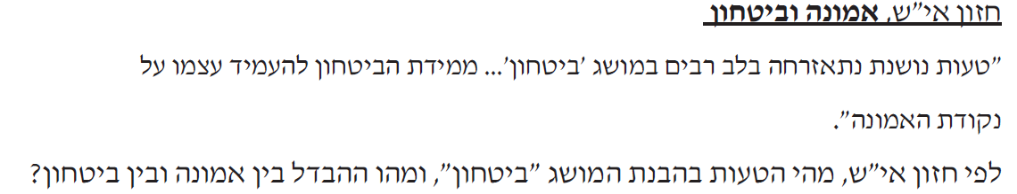
______________________________________________________________________________________________________________________________________________________________________________________________________________________________

2. קיץ תשע"ה
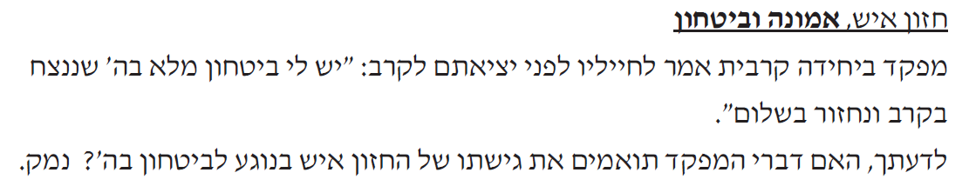
____________________________________________________________________________________________________________________________________________________
3. קיץ תשע"ז
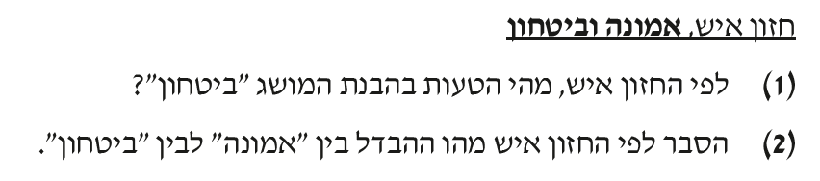
______________________________________________________________________________________________________________________________________________________________________________________________________________________________

יא. גמרא מסכת נידה , מדרש הגדול - בראשית פרק יב
- קיץ תשע"ד
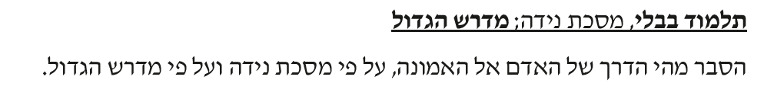
__________________________________________________________________________________________________________________________________________________________________________________________

2. קיץ תשע"ו
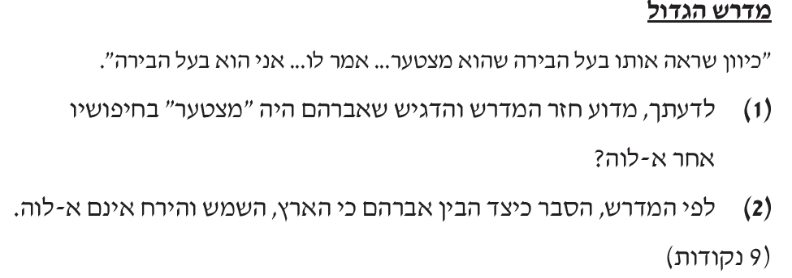
______________________________________________________________________________________________________________________________________________________________________________________________________________________________
3. קיץ תשע"ז
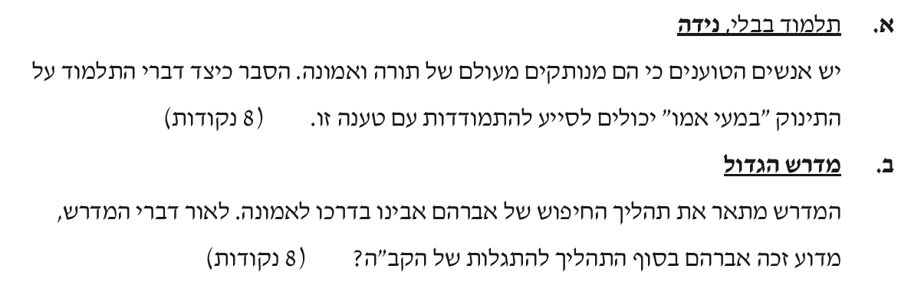
________________________________________________________________________________________________________________________________________________________________________________________________________________________________________________________________________________________________________

יב. מכתב מאליהו כרך ג עמ' 161-163 - הרב אליהו דסלר
- קיץ תשע"ה
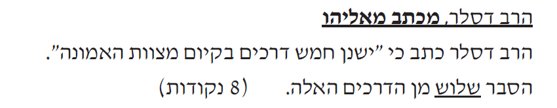
________________________________________________________________________________________________________________________________________________________________________________________________________________________________________________________________________________________________________

2. חורף תשע"ח
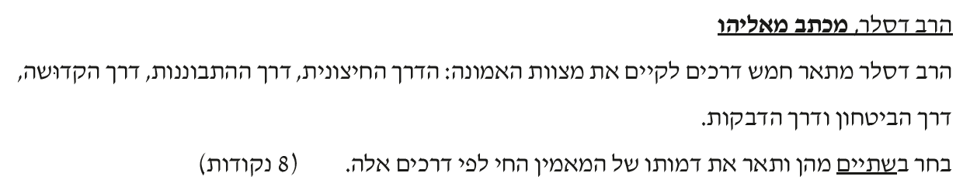
______________________________________________________________________________________________________________________________________________________________________________________________________________________________
3. קיץ תשע"ח
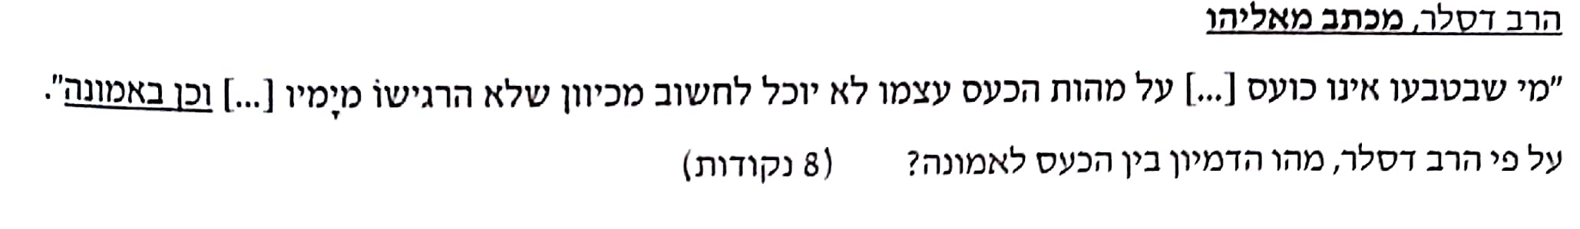
______________________________________________________________________________________________________________________________________________________________________________________________________________________________

יג. הרב קוק - אורות הקודש חלק ג עמ' קמ' -"בקשת האני העצמי"
- קיץ תשע"ג
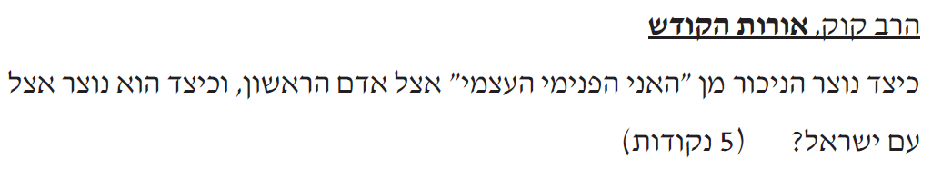
____________________________________________________________________________________________________________________________________________________ 2. קיץ תשע"ו
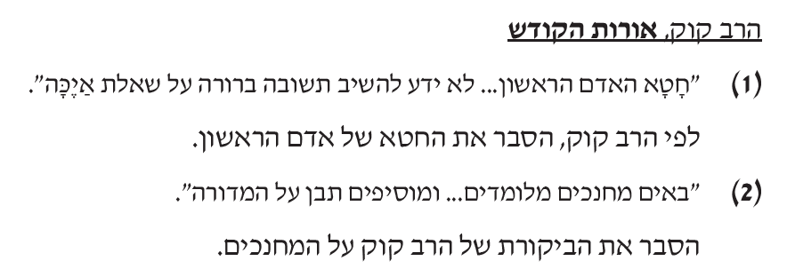
______________________________________________________________________________________________________________________________________________________________________________________________________________________________

3. קיץ תשע"ז
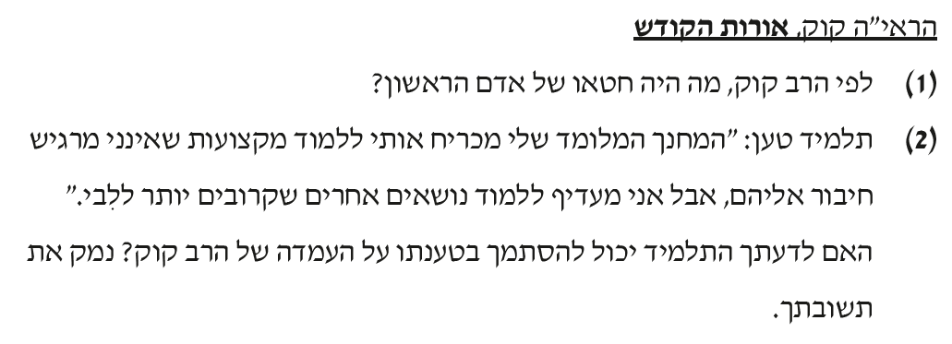
________________________________________________________________________________________________________________________________________________________________________________________________________________________________________________________________________________________________________

4. קיץ תשע"ח
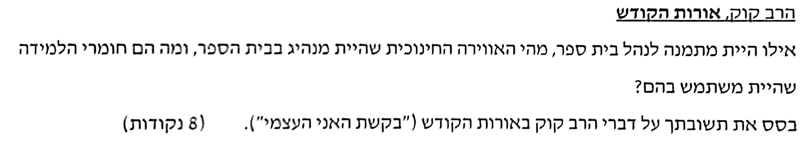
________________________________________________________________________________________________________________________________________________________________________________________________________________________________________________________________________________________________________

יד.הרב קוק - אורות התורה , פרק ט, פסקה ו
- קיץ תשע"ב
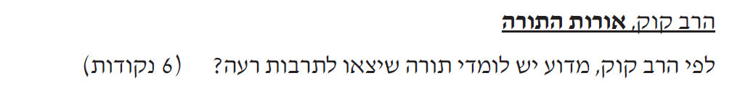
________________________________________________________________________________________________________________________________________

2. חורף תשע"ז
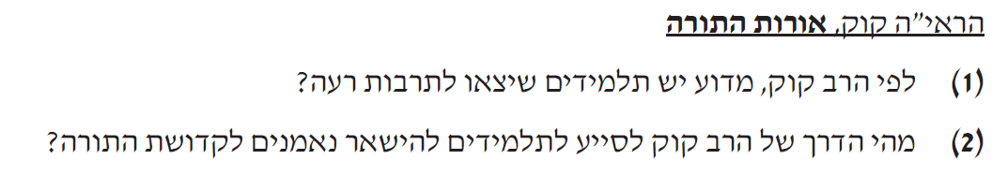
______________________________________________________________________________________________________________________________________________________________________________________________________________________________

טו.הרב שמעון שקופ - הקדמה לספרו " שערי יושר"
- קיץ תשע"ד
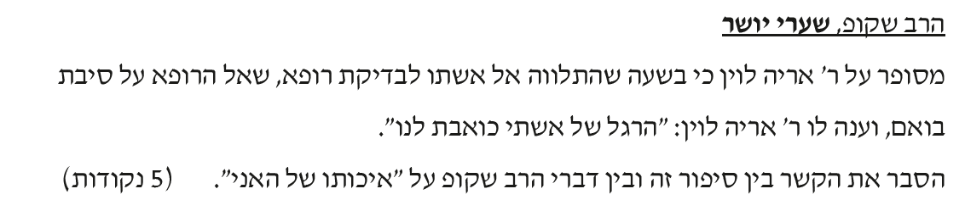
______________________________________________________________________________________________________________________________________________________________________________________________________________________________

2. קיץ תשע"ו
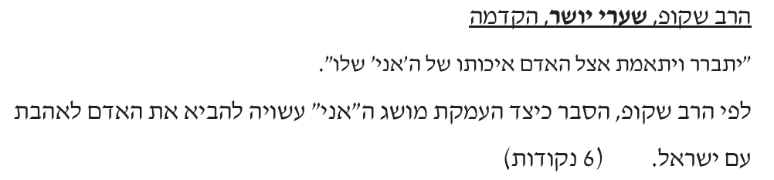
______________________________________________________________________________________________________________________________________________________________________________________________________________________________
3. קיץ תשע"ז - בדיוק כמו בשנת תשע"ד.

טז.רבי יהודה הלוי - ספר "כוזרי" מאמר שלישי סעיפים יח-יט
- קיץ תשע"ג
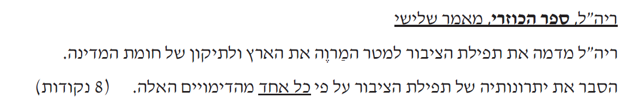
______________________________________________________________________________________________________________________________________________________________________________________________________________________________

- חורף תשע"ז
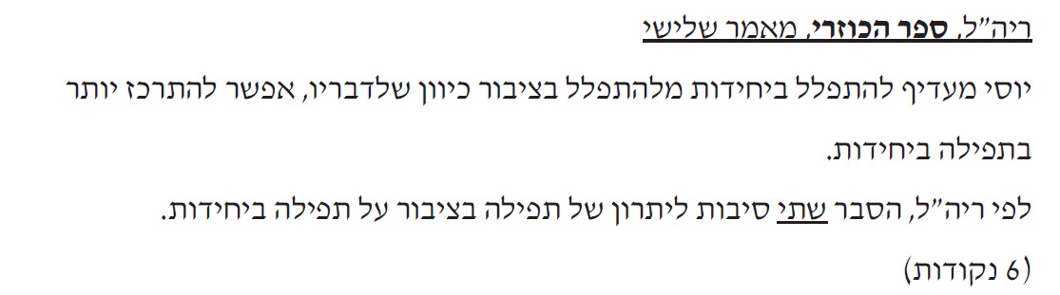
__________________________________________________________________________________________________________________________________________________

יז. הרב יוסף דב סולוביצ'יק- קול דודי דופק איש האמונה עמ' 71-74

- קיץ תשע"ג
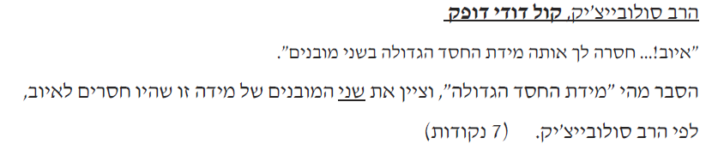
______________________________________________________________________________________________________________________________________________________________________________________________________________________________

2. קיץ תשע"ו
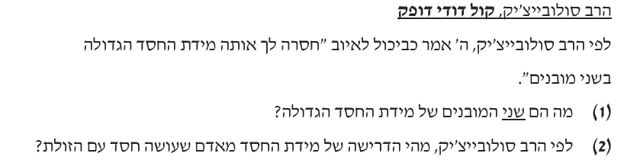

______________________________________________________________________________________________________________________________________________________________________________________________________________________________

יח. רבי יהודה הלוי - ספר "כוזרי" מאמר ראשון
- קיץ תשע"ג
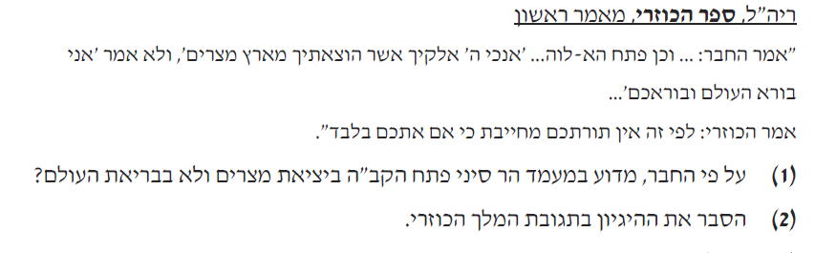
__________________________________________________________________________________________________________________________________________________________________________________________________________________________

2. קיץ תשע"ד
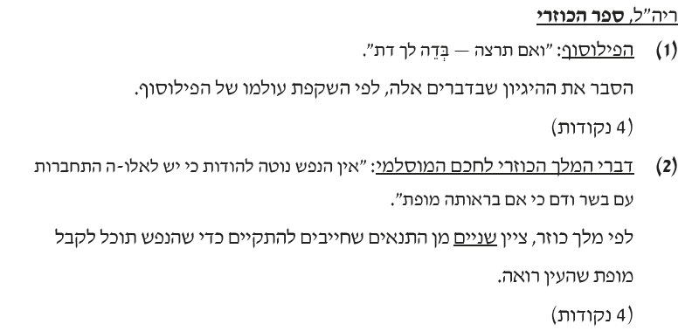
________________________________________________________________________________________________________________________________________________________________________________________________________________________________________________________________________________________________________
3. קיץ תשע"ו
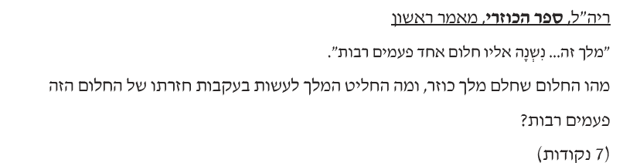
_____________________________________________________________________________________________________________________________________________________________________________________________________________________________
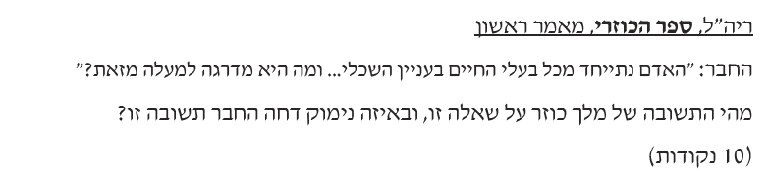
______________________________________________________________________________________________________________________________________________________________________________________________________________________________

4. חורף תשע"ח
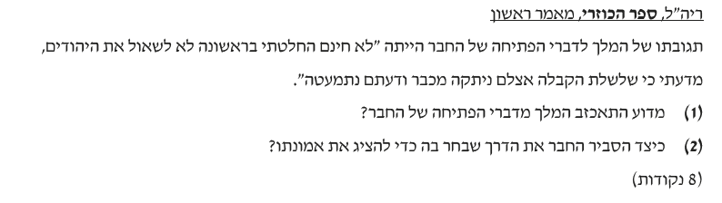
______________________________________________________________________________________________________________________________________________________________________________________________________________________________
5. קיץ תשע"ח
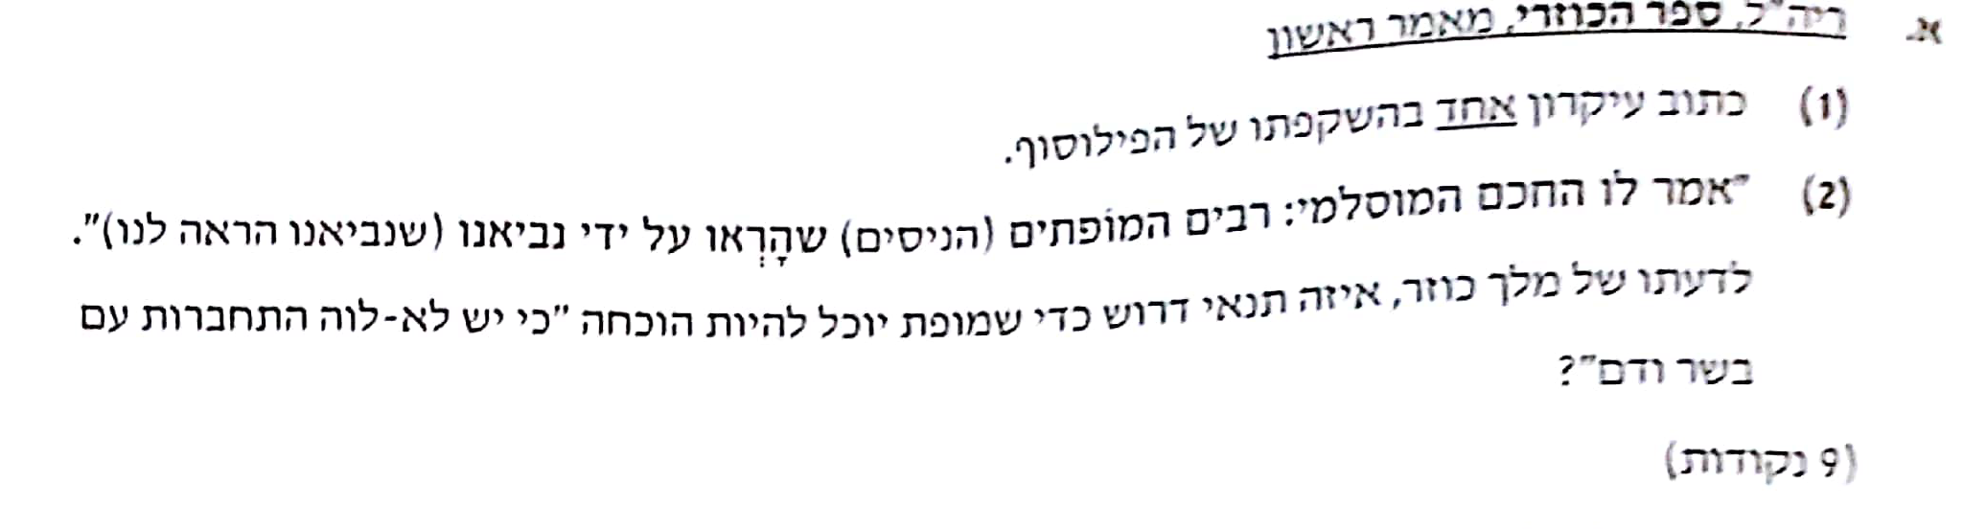
______________________________________________________________________________________________________________________________________________________________________________________________________________________________

יט. רמב"ם - איגרת תימן
- קיץ תשע"ב

________________________________________________________________________________________________________________________________________

2. קיץ תשע"ה
____________________________________________________________________________________________________________________________________________________
_________________________________________________________________________

כ. הרב קוק - "למהלך האידיאות בישראל", פרק ב , אורות ,עמ' קד'
- קיץ תשע"ה
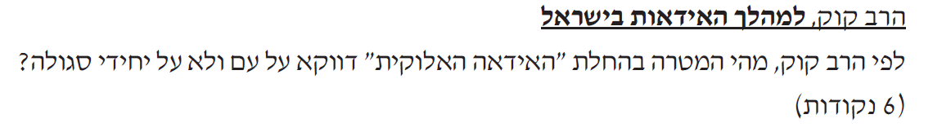
____________________________________________________________________________________________________________________________________________________
2. חורף תשע"ח
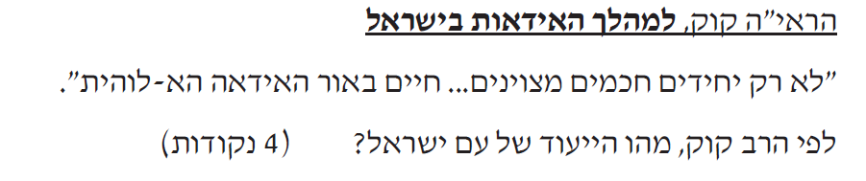
____________________________________________________________________________________________________________________________________________________
כא. הרב קוק - אגרות הראי"ה ,חלק ב , אגרת תקנ"ה
1.קיץ תשע"ג 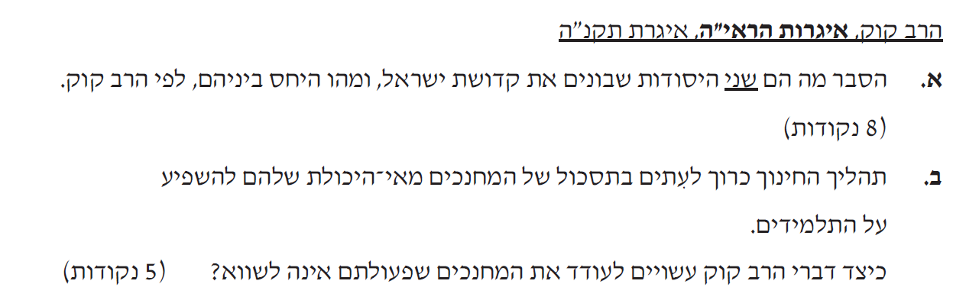
________________________________________________________________________________________________________________________________________________________________________________________________________________________________________________________________________________________________________

2. קיץ תשע"ד
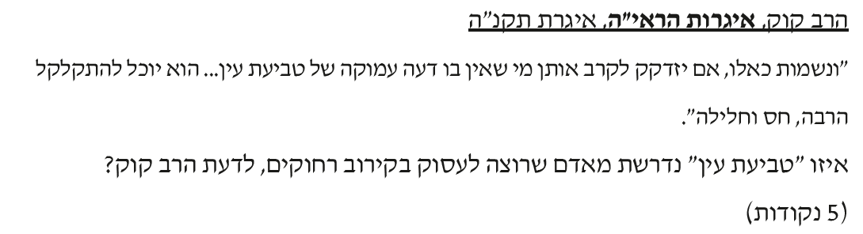
____________________________________________________________________________________________________________________________________________________
__________________________________________________________________________

3. חורף תשע"ז
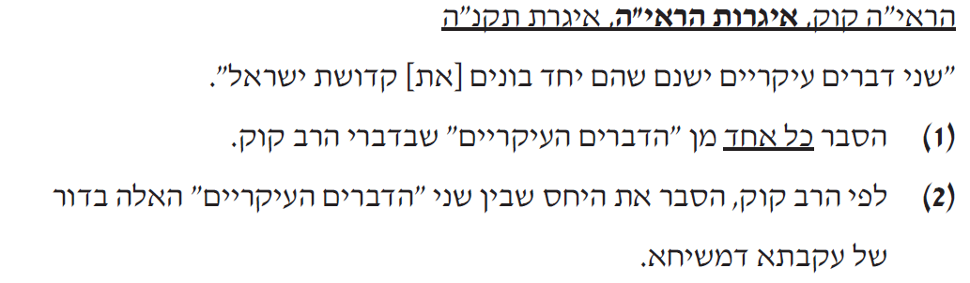
________________________________________________________________________________________________________________________________________________________________________________________________________________________________________________________________________________________________________
4. חורף תשע"ח
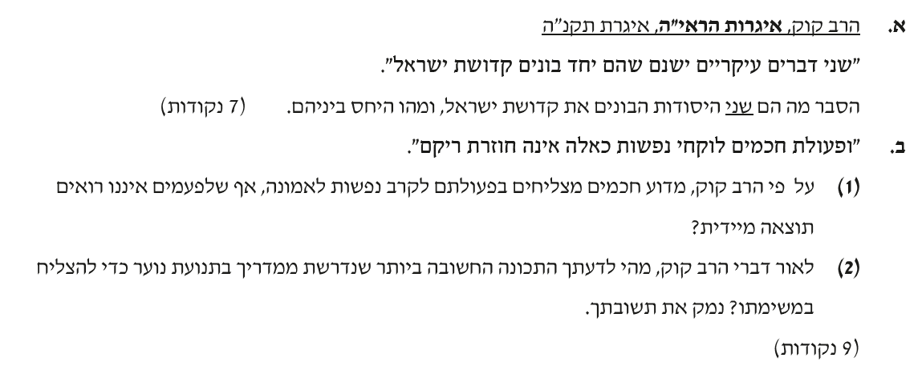
__________________________________________________________________________________________________________________________________________________________________________________________________________________________________________________________________________________________________________________________________________________________________________________

כב. "בן איש חי"

- קיץ תשע"ח
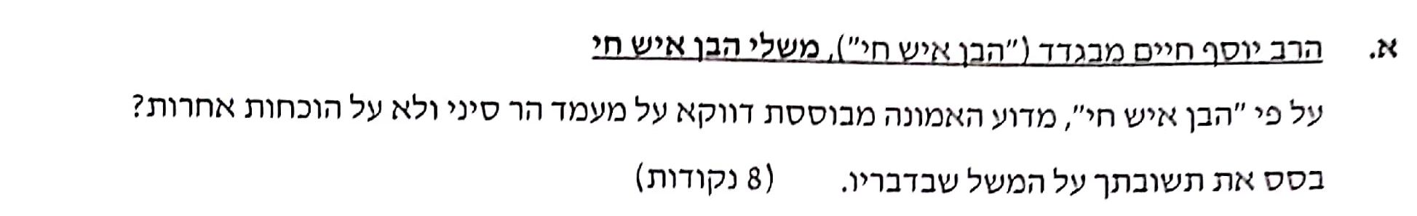
______________________________________________________________________________________________________________________________________________________________________________________________________________________________

בהצלחה רבה !!!!!

