בהצלחה רבה!!!!

הרב קוק "אורות הקודש" , חלק א , עמ' קעו- קעז / "חדריו" עמ' סו-סז
[בשאלות 3-4 צריך גם להתייחס למקור נוסף - הקדמת הרב קוק לשיר השירים]
- קיץ תשע"ד
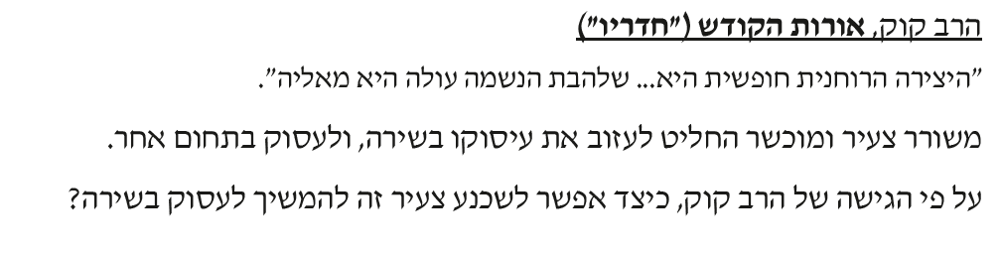
______________________________________________________________________________________________________________________________________________________________________________

2. חורף תשע"ז
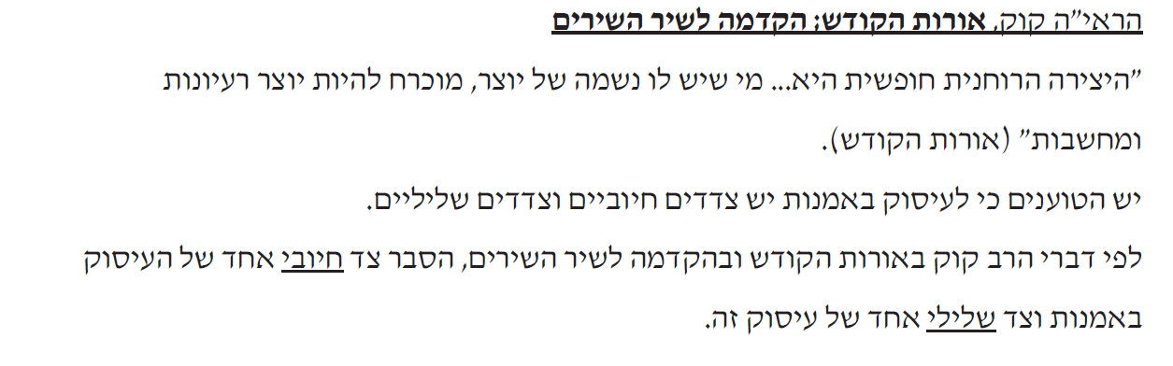
_____________________________________________________________________________________________________________________________________________________________________________________________
3. קיץ תשע"ז
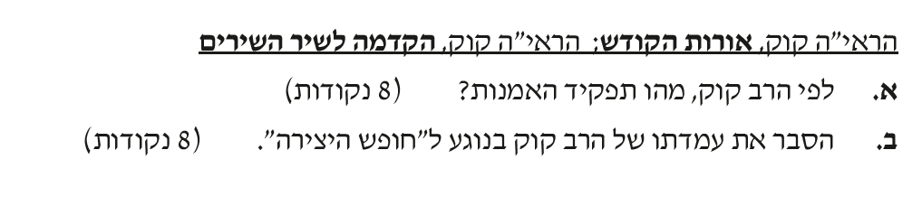
____________________________________________________________________________________________________________________________________________________________________________________________________________________________________________________________

איגרת הראי"ה לבית הספר לאמנות "בצלאל" [ אגרות הראי"ה ,א, אגרת קנ"ח]
- קיץ תשע"ד
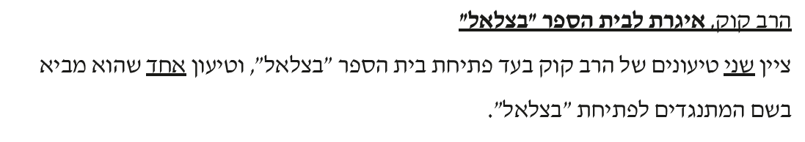
______________________________________________________________________________________________________________________________________________________________________________

2. קיץ תשע"ה
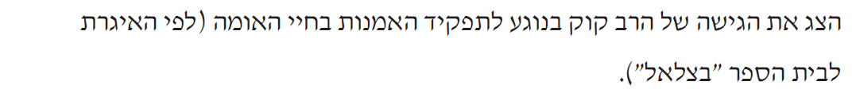
_____________________________________________________________________________________________________________________________________________________________________________________________

3. חורף תשע"ח
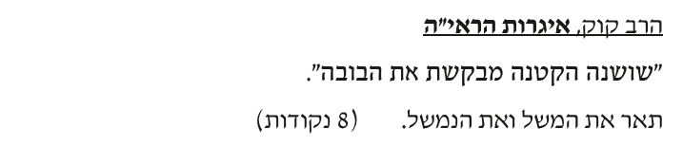
___________________________________________________________________________________________________________________________________________________________________________________________________________________________________________________________________________________________________________________________

הקדמת הרב קוק לשיר השירים
- קיץ תשע"ב
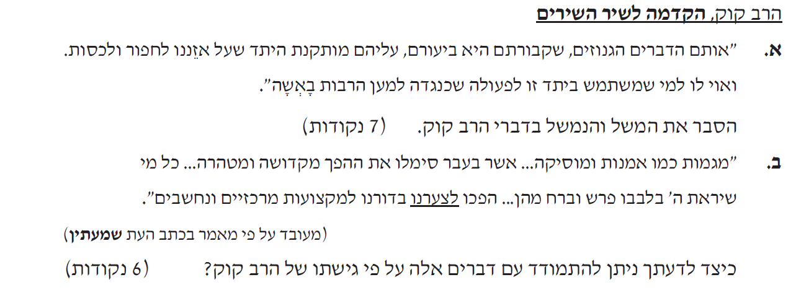
__________________________________________________________________________________________________________________________________________________________________________________________________________________________________________________________________________________________________________________________________________________________________________________________

2. קיץ תשע"ג
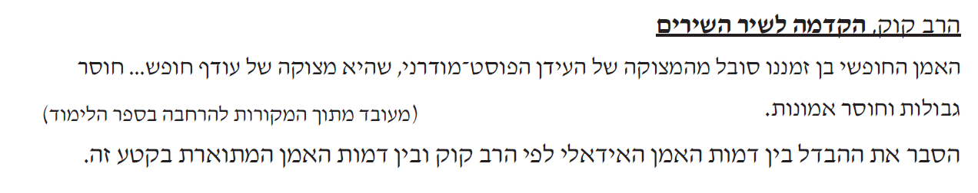
____________________________________________________________________________________________________________________________________________________________________________________________________________________________________________________________

3. קיץ תשע"ה
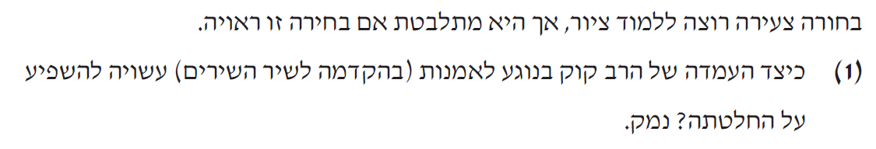
____________________________________________________________________________________________________________________________________________________________________________________________________________________________________________________________
4. קיץ תשע"ו
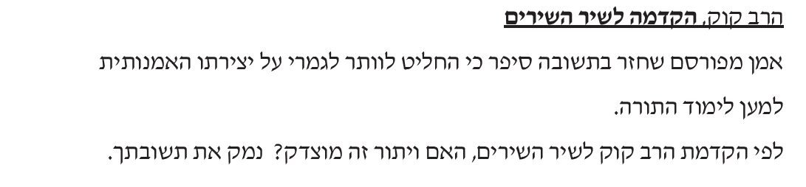
_____________________________________________________________________________________________________________________________________________________________________________________________

5. קיץ תשע"ו
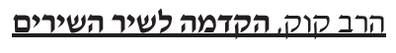
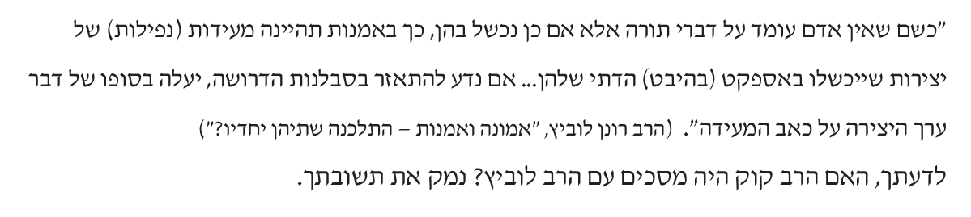
_____________________________________________________________________________________________________________________________________________________________________________________________

6. חורף תשע"ח
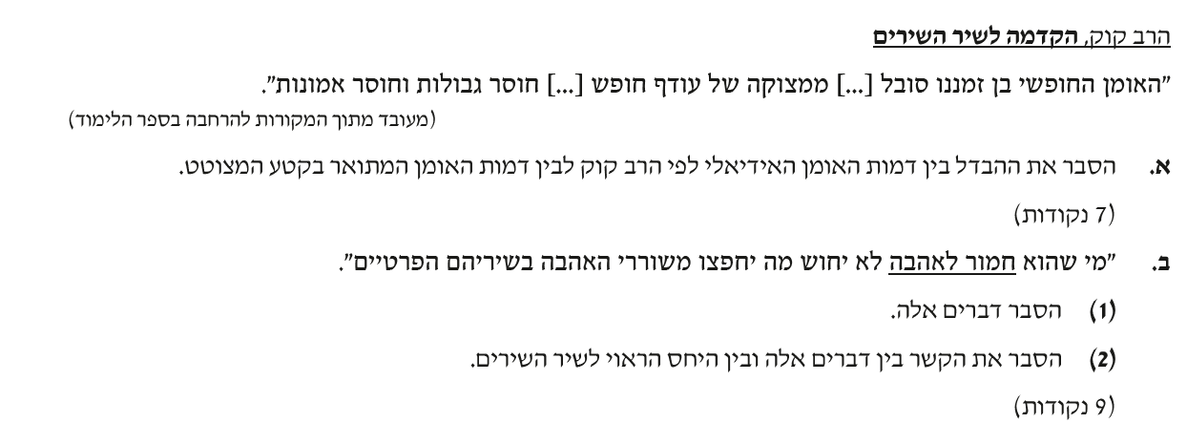
____________________________________________________________________________________________________________________________________________________________________________________________________________________________________________________________

7. קיץ תשע"ח
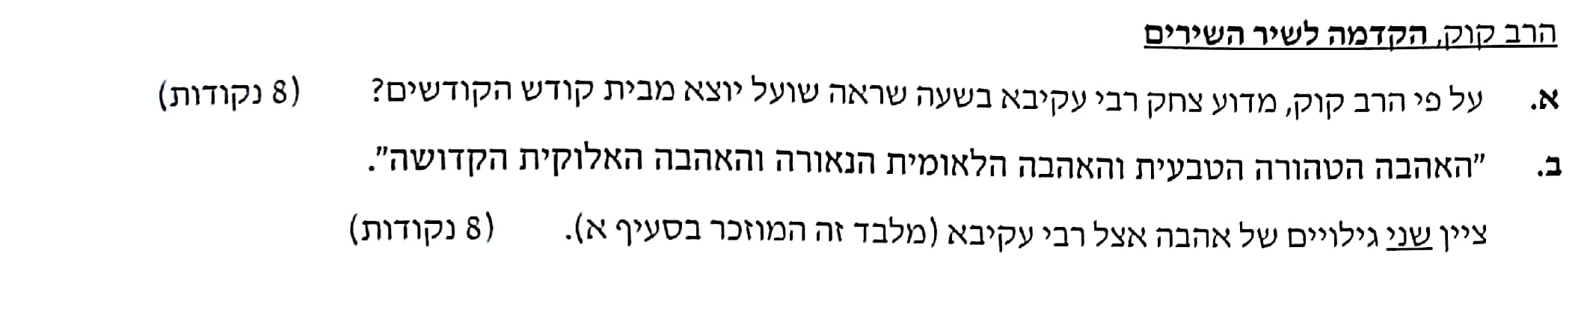
___________________________________________________________________________________________________________________________________________________________________________________________________________________________________________________________________________________________________________________________

הרב ויינברג - שו"ת [ שאלות ותשובות] "שרידי אש"
- קיץ תשע"ב
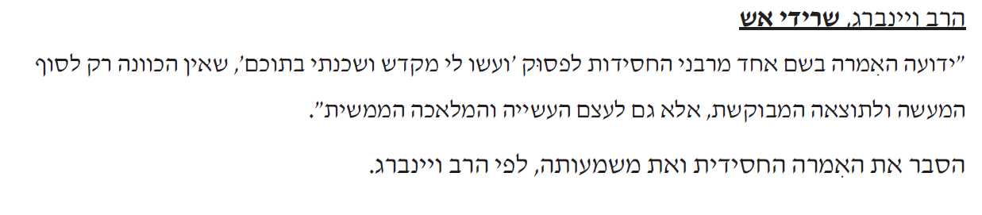
____________________________________________________________________________________________________________________________________________________________________________________________________________________________________________________________

2. קיץ תשע"ג
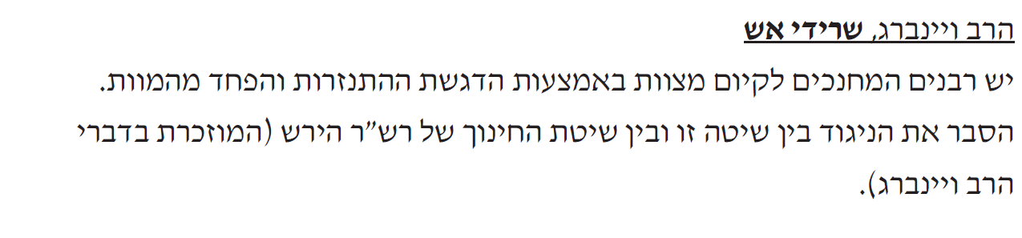
____________________________________________________________________________________________________________________________________________________________________________________________________________________________________________________________

3. קיץ תשע"ה
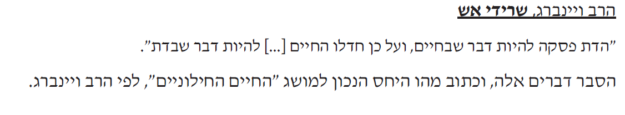
____________________________________________________________________________________________________________________________________________________________________________________________________________________________________________________________

4. חורף תשע"ז
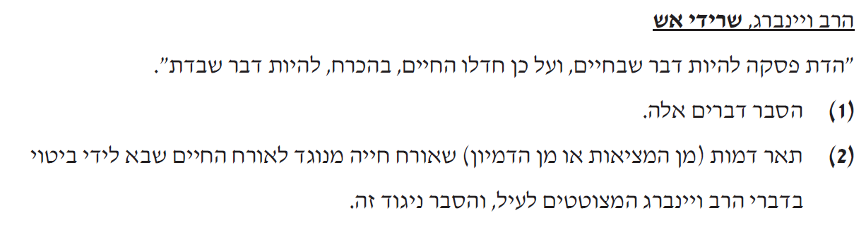
_____________________________________________________________________________________________________________________________________________________________________________________________________________________________________________________________________________________________________________________________________________________________________________

5. קיץ תשע"ז
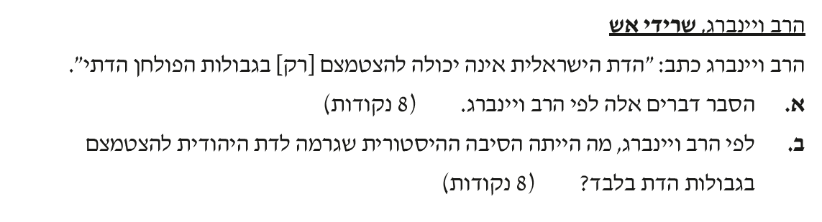
___________________________________________________________________________________________________________________________________________________________________________________________________________________________________________________________________________________________________________________________

6. חורף תשע"ח
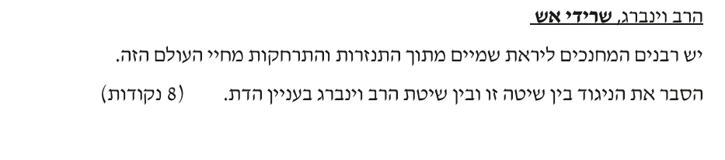
_____________________________________________________________________________________________________________________________________________________________________________________________

7. קיץ תשע"ח



